DAA LAB WORKSHEET-3

NAME: SWETHA M
ROLL NO: CH.SC.U4CSE24248

- BFS
CODE:
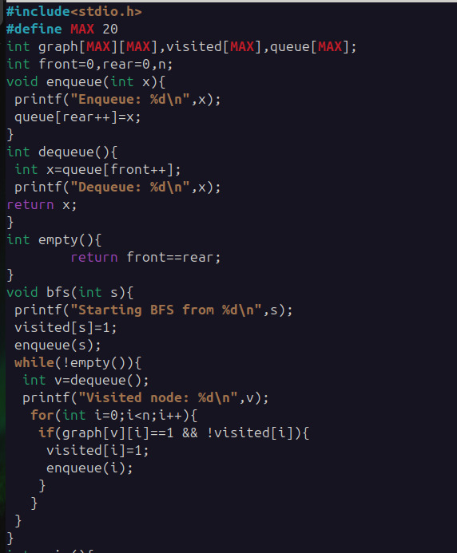
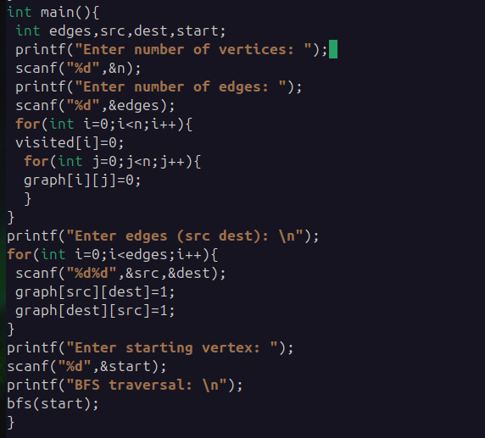

OUTPUT:

- DFS
CODE:
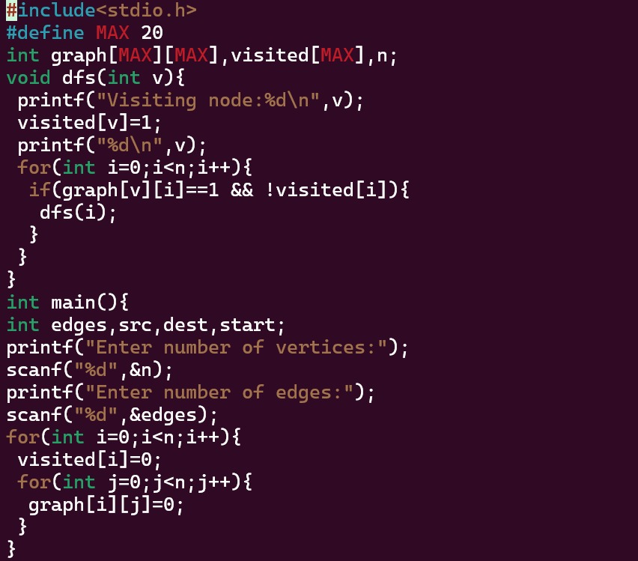
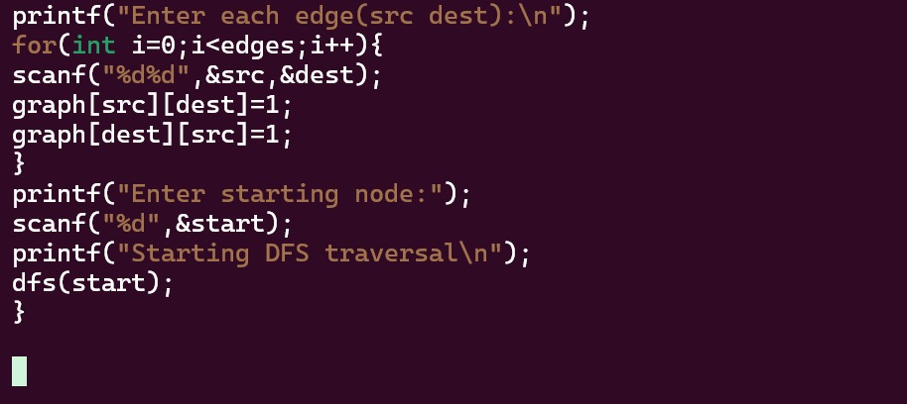

OUTPUT:
